

**PROJECT DESIGN PHASE**

**-**

**II**



**TECHNOLOGY ARCHITECTURE AND**



**TECHNOLOGY STACK**



Date



03



2022



October



Team ID



Project Name



Car Resale Value Prediction



Maximum Marks



4



Marks



**TECHNICAL ARCHITECTURE:**



The Deliverable shall include the architectural diagram as below and the information as per the table

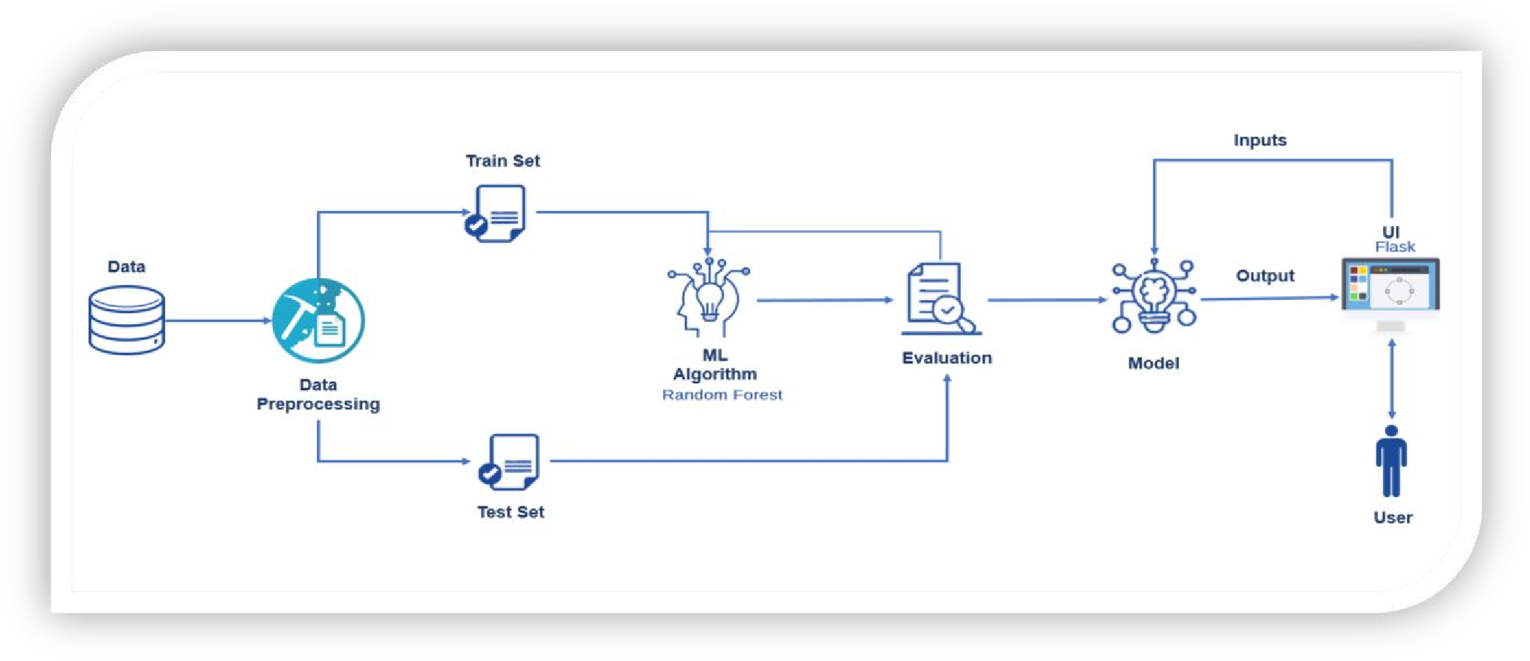

PNT2022TMID09895



**Table**

**-**

**1**

**: Components & Technologies**

**:**



**S.No**



**Component**



**Technology**



1.



User Interface



HTML, CSS



2.



Application Logic

-

1



Python



3.



Application Logic

-

2



IBM Watson



4.



Machine Learning Model



Random

forest

regressi

on



**Table**

**-**

**2:**

**Application Characteristics**

**:**



**S.No**



**Characteristics**



**Technology**



1.



Open

-

Source Frameworks



Flask



2.



Performance



It can handle

many

user

request at a time

